Module 3: IAM Policies
Assignment
IAM-Policies-Assignment-–-2

Problem Statement:
You work for XYZ Corporation. To maintain the security of the AWS account and
the resources you have been asked to implement a solution that can help easily
recognize and monitor the different users.
Tasks To Be Performed:
1. Create policy number 1 which lets the users to:
a. Access S3 completely
b. Only create EC2 instances
c. Full access to RDS
2. Create a policy number 2 which allows the users to:
a. Access CloudWatch and billing completely
b. Can only list EC2 and S3 resources
3. Attach policy number 1 to the Dev Team from task 1
4. Attach policy number 2 to Ops Team from task 1

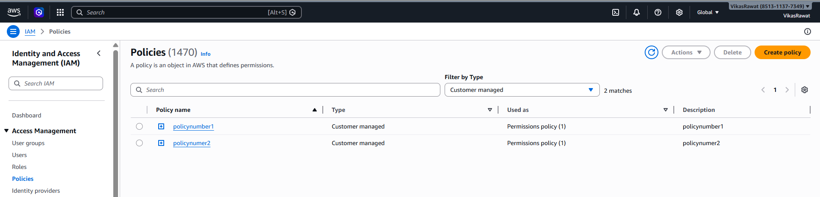
{
"Version": "2012-10-17",
"Statement": [
{
"Sid": "FullAccessS3",
"Effect": "Allow",
"Action": "s3:*",
"Resource": "*"
},
{
"Sid": "FullAccessRDS",
"Effect": "Allow",
"Action": "rds:*",
"Resource": "*"
},
{
"Sid": "OnlyCreateEC2",
"Effect": "Allow",
"Action": [
"ec2:RunInstances"
],
"Resource": "*"
},
{
"Sid": "EC2ConsoleVisibility",
"Effect": "Allow",
"Action": [
"ec2:Describe*"
],
"Resource": "*"
}
]
}

{
"Version": "2012-10-17",
"Statement": [
{
"Sid": "FullCloudWatchAndBilling",
"Effect": "Allow",
"Action": [
"cloudwatch:*",
"logs:*",
"events:*",
"aws-portal:*",
"billing:*",
"ce:*",
"budgets:*"
],
"Resource": "*"
},
{
"Sid": "ListOnlyEC2AndS3",
"Effect": "Allow",
"Action": [
"ec2:Describe*",
"s3:ListAllMyBuckets",
"s3:ListBucket",
"s3:GetBucketLocation"
],
"Resource": "*"
}
]
}
